# Network Security, test 1

1. What is the command you use to display running processes?  
     
     
   It usually contains a lot of output. What can you do to just show lines that contain a word you are interested in?
2. What is the difference between User Mode and Kernel Mode?
3. How would you redirect output from some command (say, cat) to a file without overwriting it?
4. What is the PATH variable used for?
5. What would this command do: chmod 741 svgsfile

# Open Book, Internet

This VM quest is based on the Dr. Who television series. This scenario works for the 12th Doctor (Peter Capaldi). So that Whovians don’t get an advantage, here is the cast of characters. All you need to know is who is good and who is evil.

* Dr. Who, or the Doctor. The hero.
* Clara Oswald. The Doctor’s traveling companion and co-hero.
* Tardis. The Doctor’s time and space travel ship.
* Davros. Evil mad scientist who created the Dalek race of cyborgs.
* Dalek. Evil cyborgs.
* Skaros. Home planet of the Daleks.

The VM you need on the Virginia Cyber Range and is named “Linux Dr Who Adventure.” Log into the VM as student (user name is student and password is student )

1. What users can run a terminal in the VM? (Hint: There’s a standard file in Linux that lists all the users; it also lists the user’s terminal. If the terminal is listed as “nologin”, “sync”, “false”, or “halt”, that user can’t run a terminal.)
2. Clara always forgets her password, so she had the Doctor save it in a file called Danny (her boyfriend’s name is Danny Pink.) She forgot where the file is, so you’ll have to find it for her. (Hint: the find command will help.) What is Clara’s password? (Hint: if the command gives so many errors that you can’t find the file, you can: pipe the output to less; use the technique in the files lesson to redirect the errors to a place where they won’t bother you; or pipe the output to something that searches for Danny.)
3. The Doctor created a directory /home/tardis.
   1. Who is the owner and what is the group for that directory? What permissions are assigned?
   2. Log in as, or switch user to clara. Can she read the Tardis Manual in /home/tardis? Can she write files? (Hint: if clara can read files try to create a file in that directory to see if she has write privileges.)
   3. Why does clara have the rights she does?
   4. Using the clara user, read the Tardis manual. How do you make the Tardis take off?
4. The Doctor can’t remember passwords either. He is in the habit of emailing his password to himself so he can find it later. He thinks it is clever to use the password as the From: address. Usually it looks like From:<password>@tardis.com and To:doctor@tardis.com. There is a large SMTP log file in /var/log/smtp. It would take a long time to page through the entire file, but you should be able to find the password with one simple command. (Don’t let it bother you that the SMTP log file is from a Windows server, but is stored on an Ubuntu machine. Weird things happen when the Doctor is involved.)
   1. What is the Doctor’s password?
5. Since the Doctor is the hero, he should have root access. Log in as doctor and see if he does. How does the Doctor access his privileges? (Hint: remember there are two ways, and both start with “su”. Try both and see if they work.)
6. Now that you have root access using the Doctor’s account, let’s go back and look at the users again. Examine /etc/shadow, and determine which of the users you found in step 1) can actually log in. (Hint: they need a valid hash. An ‘!’ in the position for the hash means the account is disabled, and an ‘*’ means no password has ever been set for that account. Valid hashes are usually long.)
7. Davros tried to create a service that runs when the machine changes run levels. He used the old sysV method for creating services. Can you find it? (Hint: Where are scripts for services put in SysV?) What is the full path to the file he made, and what does it do when executed? (The answer to this question is a strong hint for the next question.)
8. The Doctor says the root password should be the same as his password, but it’s not. It appears Davros has changed it. Can you guess the root password? What is it? (Hint: see the answer for question 7.)
9. Davros was successful in installing a back door that is listening to the network. Use the techniques you learned in the lab on unnecessary services to find it. Note: the open TCP port 3389 is what VA Cyber Range uses to allow you to get a GUI connection to your VM. Don’t mess with it. There are two other open TCP ports; one is normal, one is not and could be a back door.
   1. Is there a suspicious port open?
   2. What is the process ID (PID)?
   3. What file or command opened the suspicious port?
10. For fun, let’s be Davros and use his back door. There is a second VM in this environment used for auditing, or checking, the main VM. To access the second VM, open a second terminal as student (su to student if you logged in with the doctor or clara accounts.) Execute this command:  
    ssh [student@audit.example.com](mailto:student@audit.example.com)  
    This will establish a Secure Shell (SSH) connection to the audit VM, and log you in with the student account on the audit server. (You don’t need a password because your account on the main VM has a private key that is allowed to log in--it’s in ~/.ssh)  
    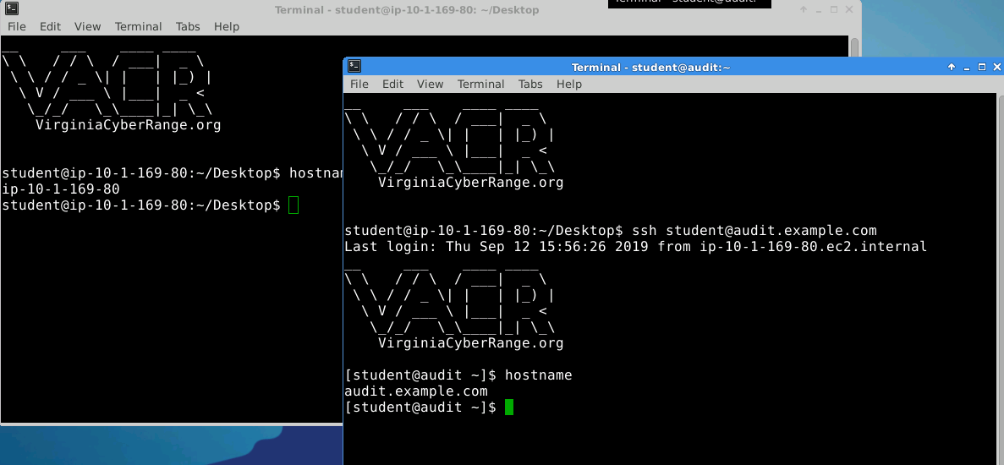  
    The image above shows a terminal in the main VM (background, grey title bar). The hostname command outputs ip-10-1-169-80, which is the name of the main VM. The foreground terminal (blue title bar) shows the ssh command (ssh [student@audit.example.com](mailto:student@audit.example.com)) and the output of the hostname shows audit.example.com. That means the foreground terminal is remotely commanding the audit VM.  
      
    We want to use the audit VM to connect to Davros’ backdoor on the main VM. To do that we will use nc (netcat), but first we will need to know:
    1. The IP address of the main VM. (You can look up the command to use to determine this, but there is an obvious give-away on this particular VM. Hint: If you are choosing between addresses, it is not 127.0.0.1; that’s the loopback address.)
    2. The port that Davros’ back door listens on. (You should have found that in step 9.)  
         
       Once you have the information, enter the command below on the audit VM. The audit VM is the one with the blue title bar where you connected with SSH. The output of its hostname command was audit.example.com.  
         
       nc [ip address of main VM] [port that Davros’ back door listens on]  
         
       Here’s an example, but with the wrong IP (10.0.0.1) and port (1234)  
       nc 10.0.0.1 1234  
         
       If the command gives no output, don’t panic! Davros’ back door is a shell, not a terminal/console. It does not give you a prompt (ex. student@ip-10-1-169-80:~$). However, if you type a command, you should get a response. In the image below, I typed hostname, and the backdoor responded with ip-10-1-169-80.  
         
       Try other commands for basic exploration, like  
       pwd (show the current directory, or print working directory)  
       whoami (show the user I’m logged in as)  
       uname -a (show all the info about the Unix version)  
       ls  
       You can also mess around with changing directories, executing programs, or whatever you want. GUI programs and nano will not work, though.  
         
       When you are finished, you can type exit or hit control-C to get your prompt back on the audit VM.  
         
       The answer to this question is a screenshot of the audit VM terminal with the response to the hostname command from Davros’ back door, just like the image above (without the whiteout, though :-)
11. (Extra Credit) If you kill the back door process, you should find that it will restart within 5 minutes. Can you (and your friend Google) find something that would cause that to happen?